
Submitted by : Spogmai Jan
Roll no : 2430 -0081
Submitted to : sir nouman asim

Computer networks
Final lab exam

TASK 01:
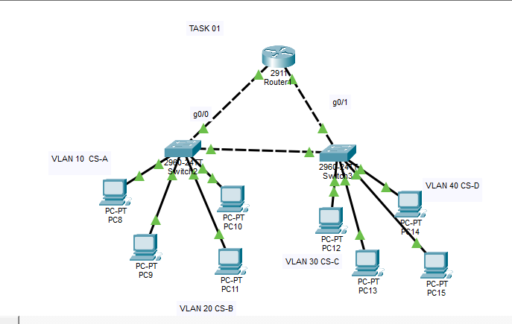

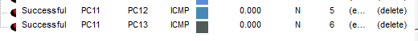
Vlan 20 and vlan 30 message has been successful.

TASK 02:



